|  |  |
| --- | --- |
| Logo_FPT_University_doc |  |

|  |
| --- |
| **FPT UNIVERSITY** |
| Capstone Project Document |

USEFUL JAPANESE DICTIONARY FOR VIETNAMESE

Report #3 – User Requirement Specification

|  |  |
| --- | --- |
| USEFUL JAPANESE DICTIONARY FOR VIETNAMESE | |
| **Group Members** | |  |  | | --- | --- | | Lê Đình Nam | SE02316 | | Phạm Thị Minh | SE02300 | | Nguyễn Ngọc Tuấn | SE02189 | | Phạm Tiến Đạt | SE02336 | |
| **Supervisor** | Mr. Nguyễn Văn Sang |
| **Project code** | UJD\_VN |

- Hanoi, 06/2014 –

Record of change

\*A - Added M - Modified D – Deleted

|  |  |  |  |  |
| --- | --- | --- | --- | --- |
| Effective Date | Changed Items | A\* M, D | Change Description | New Version |
| 23/06/2014 | Screen design | A | Create new | v0.1 |
|  |  |  |  |  |
|  |  |  |  |  |
|  |  |  |  |  |

**Signature page**

**Riginator** Nguyễn Ngọc Tuấn 23/06/2014

Team member

**Reviewer**  Nguyễn Ngọc Tuấn

Team member

**Approval** Nguyễn Văn Sang

Supervisor

Table of Contents

[1 Introduction 4](#_Toc391716799)

[*1.1* Purpose 4](#_Toc391716800)

[*1.2* Definitions, Acronyms and Abbreviations 4](#_Toc391716801)

[*1.3* References 4](#_Toc391716802)

[*1.4* Overview 5](#_Toc391716803)

[2 Screen Flow 6](#_Toc391716804)

[*2.1* Search screen 8](#_Toc391716805)

[*2.2* Login 8](#_Toc391716806)

[*2.3* Register 9](#_Toc391716807)

[*2.4* Edit profile 10](#_Toc391716808)

[*2.5* Forgot password 12](#_Toc391716809)

[*2.6* Contribute content 13](#_Toc391716810)

[*2.7* Contribute opinion 14](#_Toc391716811)

[*2.8* Send Q&A 15](#_Toc391716812)

[*2.9* Elementary 16](#_Toc391716813)

[*2.10* Intermediate 16](#_Toc391716814)

[*2.11* Review 20](#_Toc391716815)

[*2.12* Listening 21](#_Toc391716816)

[*2.13* Conversation 23](#_Toc391716817)

[*2.14* Test 24](#_Toc391716818)

[3 Other considerations 27](#_Toc391716819)

# Introduction

## Purpose

To ensure consistency and simplicity in detailed design across all displays within a product interface, as well as across other products used by the same users.  Definitions, acronyms, abbreviations, references and overview of UJD\_VN website

## Definitions, Acronyms and Abbreviations

|  |  |  |
| --- | --- | --- |
| Abbreviations | Description | Comment |
| UJD\_VN | Useful Japanese dictionary for Vietnamese |  |
| Q&A | Question and answer |  |
|  |  |  |
|  |  |  |

## References

|  |  |
| --- | --- |
| Document Number | Title |
|  |  |

## Overview

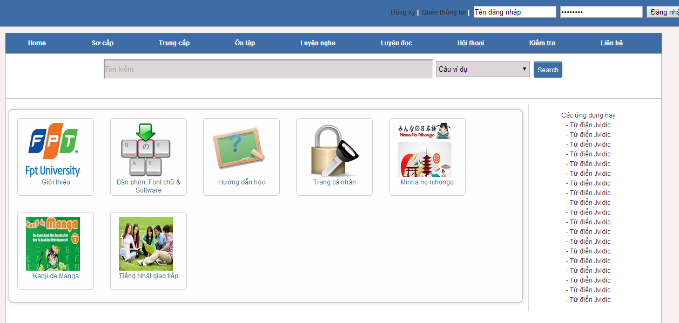

# Screen Flow

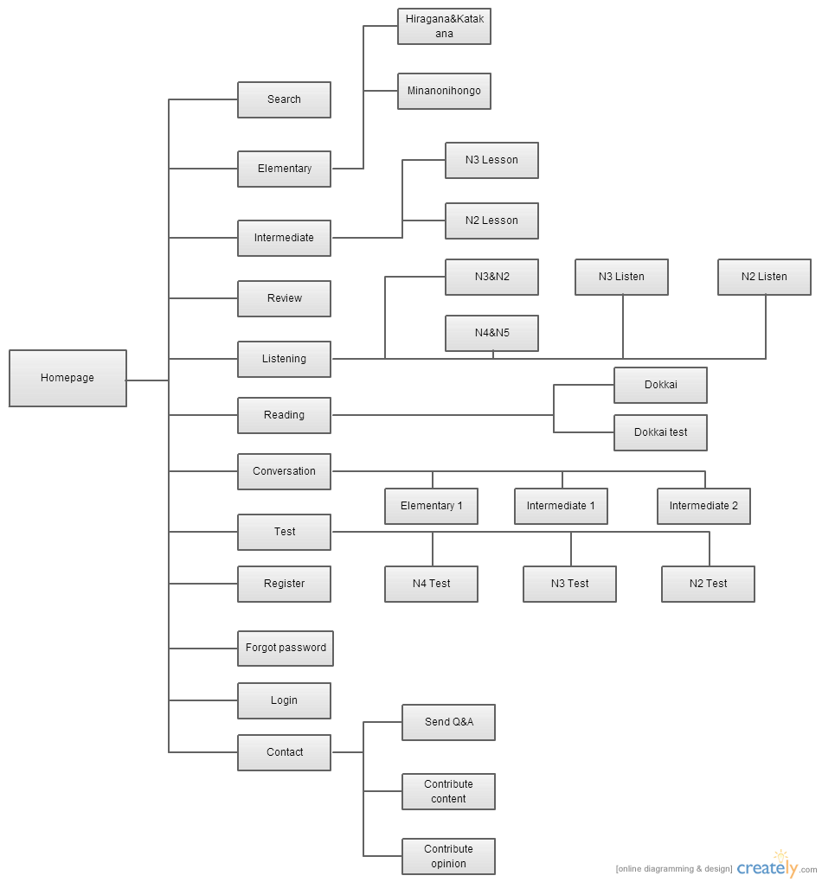

|  |  |  |  |
| --- | --- | --- | --- |
| No | Screen Name | | Description |
| 1 | Homepage | | Homepage |
| 2 | Search | | Search |
| 3 | Login | | Login as a member |
| 4 | Register | | Create new account |
| 5 | Forgot password | | Contact to admin to receive password |
|  | Elementary | Hiragana & Katakana | Hiragana & Katakana letter |
| Minanonihongo | 50 lesson of MinanoNihongo |
|  | Intermediate | N3 lesson | N3 Lesson ( Reading, Kanji, Grammar, Vocabulary) |
| N2 lesson | N2 Lesson ( Reading, Kanji, Grammar, Vocabulary) |
|  | Listening | N2&N3 | N3&N2 Listening |
| N4&N5 | N4&N5 Listening |
| N2 Listen | N2 Listening |
| N3 Listen | N3 Listening |
|  | Review | | Review |
|  | Reading | Dokkai | Reading lesson |
| Dokkai test | Reading test |
|  | Test | N4 Test | Doing test N4 |
| N3 Test | Doing test N3 |
| N2 Test | Doing test N2 |
|  | Conversation | Elementary 1 | Listening conversation of elementary |
| Intermediate 1 | Listening conversation of intermediate |
| Intermediate 2 | Listening conversation of intermediate |
|  | Contact | Send Q&A | Send Q&A to admin |
| Contribute content | Contribute content for website |
| Contribute opinion | Contribute opinion for website |

## Search screen

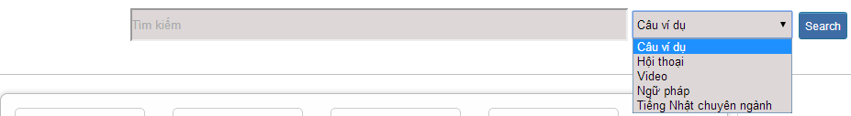

|  |  |  |  |  |  |  |
| --- | --- | --- | --- | --- | --- | --- |
| No | Field name | Type | Require | Mandatory | Length | Description |
| 1 | Searcharea | Text | Text | Y | 200 | User input a new word with length less than 200 characters |
| 2 | SearchOption | Drop-down list | Click | Y |  | User choose type of search |
| 2 | Search | Button | Click | Y |  | User click on search button |

## Login



|  |  |  |  |  |  |  |
| --- | --- | --- | --- | --- | --- | --- |
| No | Field name | Type | Require | Mandatory | Length | Description |
| 1 | Username | Text | Text | Y | 32 | User input username with length less than 32 character |
| 2 | Password | Password | Text | Y | 32 | User input their password with length less than 32 characters |
| 3 | Login | Button | Click | Y |  | User click on Login button |

## Register

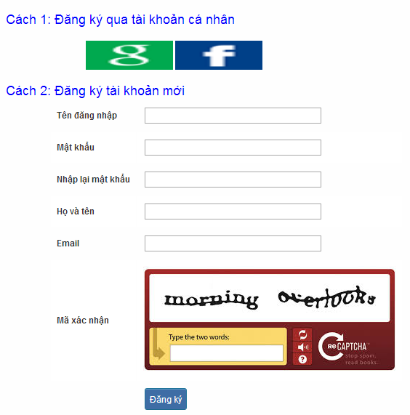

|  |  |  |  |  |  |  |
| --- | --- | --- | --- | --- | --- | --- |
| No | Field name | Type | Require | Mandatory | Length | Description |
| 1 | Username | Text | Text | Y | 32 | User input username with length less than 32 characters |
| 2 | Password | Password | Text | Y | 32 | User input their password with length less than 32 characters |
| 3 | Repassword | Password | Text | Y | 32 | User re-input password with length less than 32 characters |
| 4 | Name | Text | Text | Y | 50 | User input their name with length less than 50 characters |
| 5 | Email | Text | Text | Y | 100 | User input email with length less than 32 characters |
| 6 | Capcha | Text | Txt | Y | 100 | User input the verification code |
| 7 | Register | Button | Click | Y |  | User click Register button |

## Edit profile

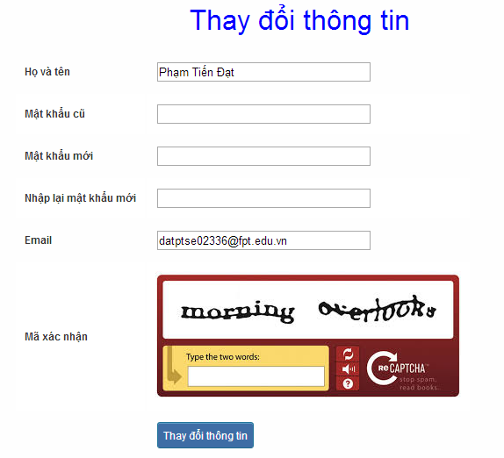

|  |  |  |  |  |  |  |
| --- | --- | --- | --- | --- | --- | --- |
| No | Field name | Type | Require | Mandatory | Length | Description |
| 1 | Name | Text | Text | Y | 32 | User input their name with length less than 32 characters |
| 2 | Old-Password | Password | Text | Y | 32 | User input their old password with length less than 32 characters |
| 3 | New-password | Password | Text | Y | 32 | User input new password with length less than 32 characters |
| 4 | Repassword | Password | Text | Y | 32 | User re-input password with length less than 32 characters |
| 5 | Email | Text | Text | Y | 100 | User input email to with length less than 100 characters |
| 6 | Capcha | Text | Text | Y | 100 | User input the verification code |
| 7 | Edit | Button | Click | Y |  | User click on Edit button |

## Forgot password

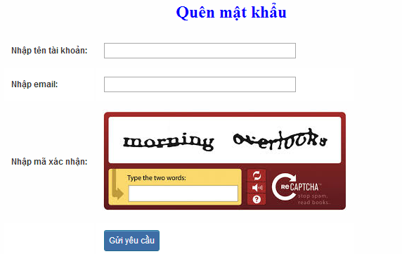

|  |  |  |  |  |  |  |
| --- | --- | --- | --- | --- | --- | --- |
| No | Field name | Type | Require | Mandatory | Length | Description |
| 1 | Username | Text | Text | Y | 32 | User input username with length less than 100 characters |
| 2 | Email | Text | Text | Y | 100 | User input email with length less than 100 characters |
| 3 | Capcha | Text | Text | Y | 100 | User input the verification code |
| 4 | Send | Button | Click | Y |  | User click on Send button |

## Contribute content

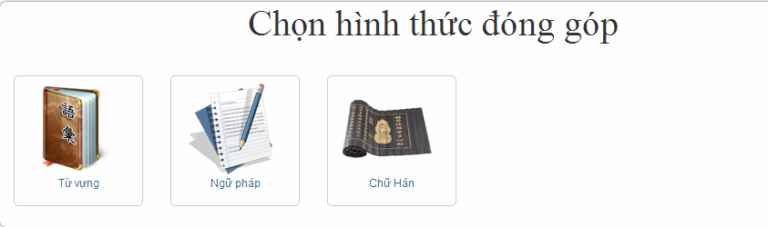

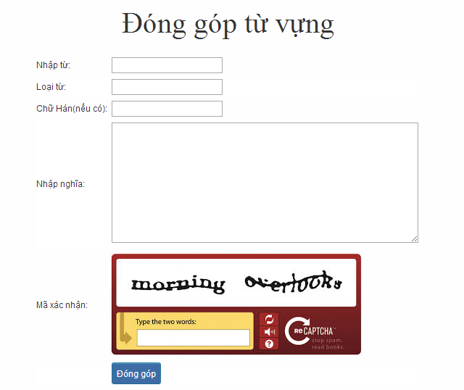

|  |  |  |  |  |  |  |
| --- | --- | --- | --- | --- | --- | --- |
| No | Field name | Type | Require | Mandatory | Length | Description |
| 1 | Tu | Text | Text | Y | 100 | User input vocabulary with length less than 100 characters |
| 2 | Loaitu | Text | Text | Y | 100 | User input kind of vocabulary with length less than 100 characters |
| 3 | Kanji | Text | Text | Y | 100 | User input kanji of vocabulary (if exist) with length less than 100 characters |
| 4 | Mean | Text | Text | Y | 100 | User input mean of vocabulary with length less than 100 characters |
| 5 | Capcha | Text | Text | Y | 100 | User input the verification code |
| 6 | Donggop | Button | Click | Y |  | User click on Donggop button |

## Contribute opinion

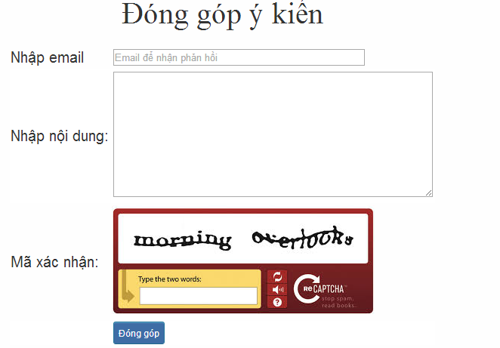

|  |  |  |  |  |  |  |
| --- | --- | --- | --- | --- | --- | --- |
| No | Field name | Type | Require | Mandatory | Length | Description |
| 1 | Email | Text | Text | Y | 100 | User input email with length less than100 characters |
| 2 | Content | Text | Text | Y | 1000 | User input content with length less than1000 characters |
| 3 | Capcha | Text | Text | Y | 100 | User input the verification code |
| 4 | Donggop | Button | Click | Y |  | User click on Donggop button |

## Send Q&A

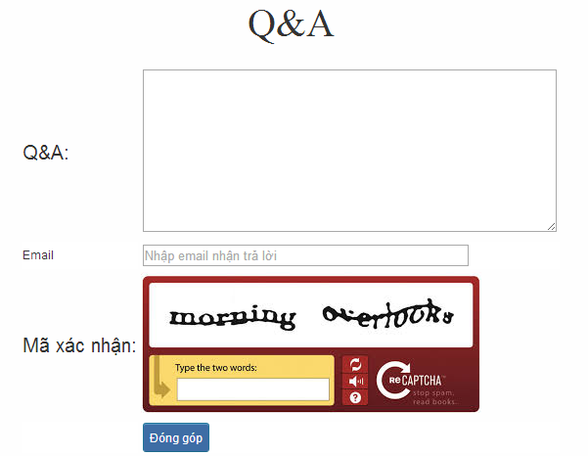

|  |  |  |  |  |  |  |
| --- | --- | --- | --- | --- | --- | --- |
| No | Field name | Type | Require | Mandatory | Length | Description |
| 1 | QA | Text | Text | Y | 1000 | User input Q&A with length less than 1000 characters |
| 2 | Email | Text | Text | Y | 100 | User input email with length less than 100 characters |
| 3 | Capcha | Text | Text | Y | 100 | User input the verification code |
| 4 | Donggop | Button | Click | Y |  | User click on Donggop button |

## Elementary

* + 1. Hiragana & Katakana

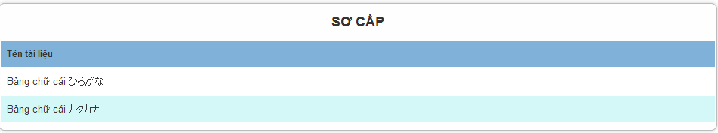

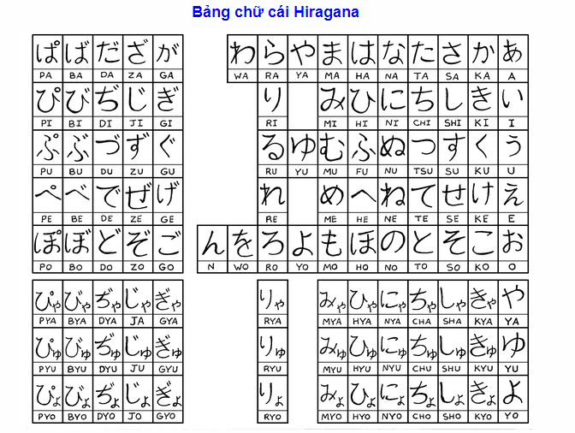

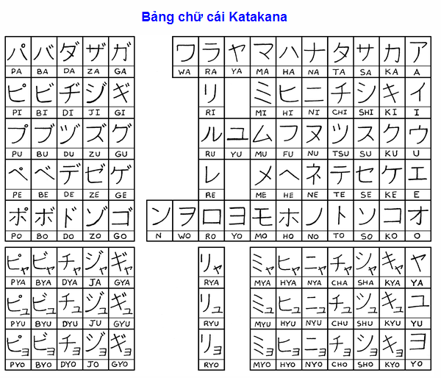

* + 1. Mina no Nihongo

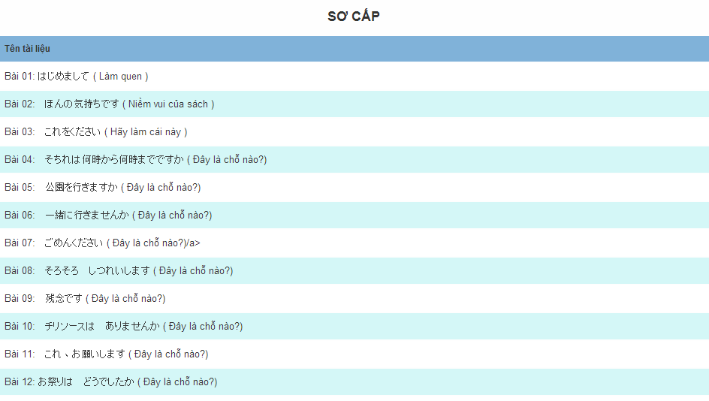

## Intermediate

* + 1. N3 Grammar

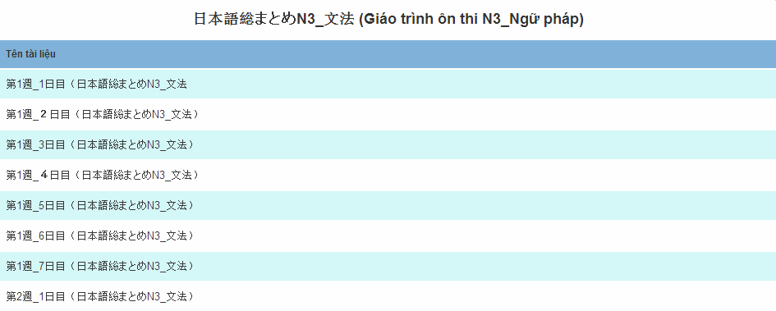

After click on hyperlink of N3 Grammar:

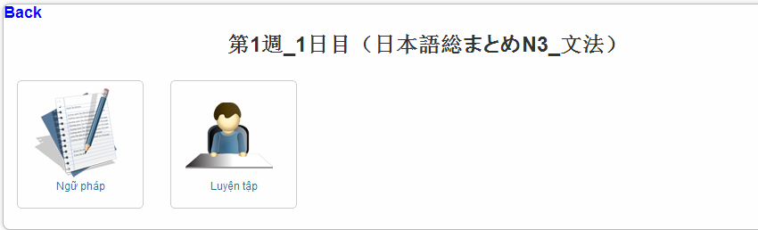

|  |  |  |  |  |  |  |
| --- | --- | --- | --- | --- | --- | --- |
| No | Field name | Type | Require | Mandatory | Length | Description |
| 1 | Back | Hyperlink | Click | N |  | Back on N3 grammar list |
| 2 | Grammar | Hyperlink | Click | Y |  | Grammar of N3 |
| 3 | Exercise | Hyperlink | Click | Y |  | Exercise of N3grammar |

Grammar screen: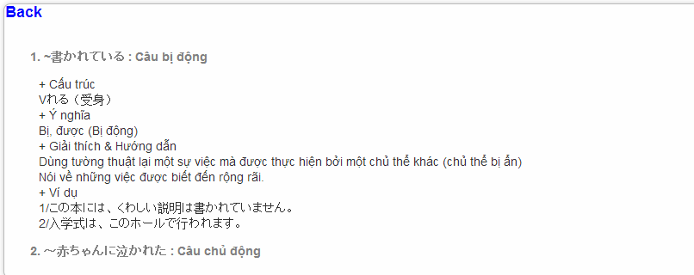

Exercise screen:

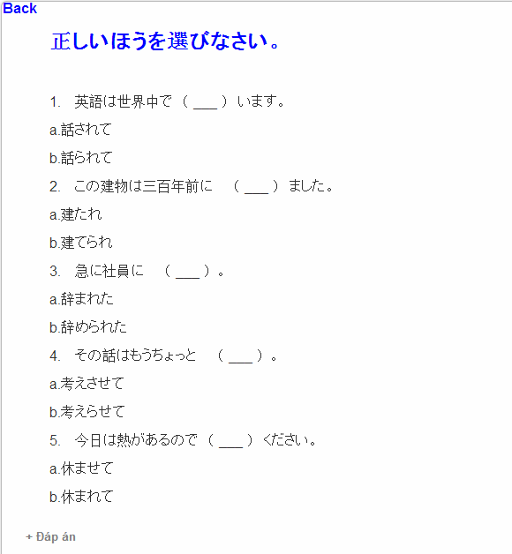

* + 1. N3 Vocabulary

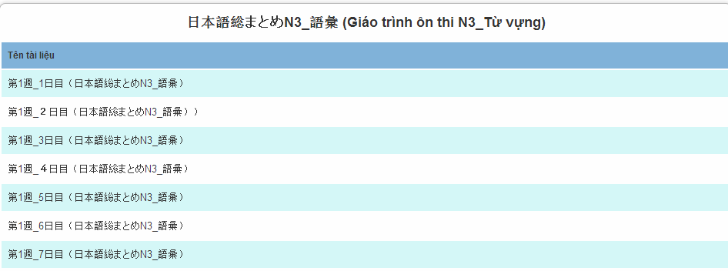

After click on hyperlink of N3 vocabulary:

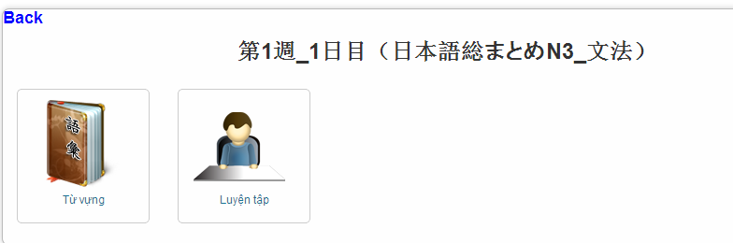

|  |  |  |  |  |  |  |
| --- | --- | --- | --- | --- | --- | --- |
| No | Field name | Type | Require | Mandatory | Length | Description |
| 1 | Back | Hyperlink | Click | N |  | Back on N3 vocabulary list |
| 2 | Vocabulary | Hyperlink | Click | Y |  | Vocabulary of N3 |
| 3 | Exercise | Hyperlink | Click | Y |  | Exercise of N3vocabulary |

Vocabulary screen:

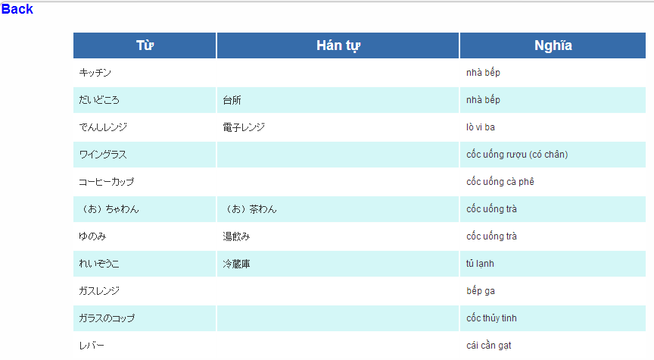

Exercise screen:

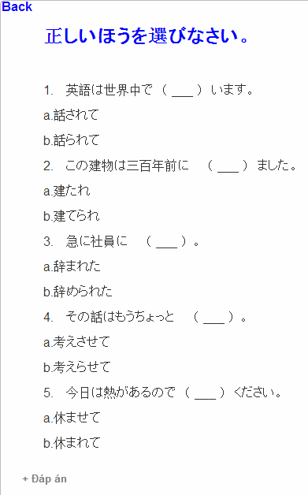

* + 1. N3 Kanji

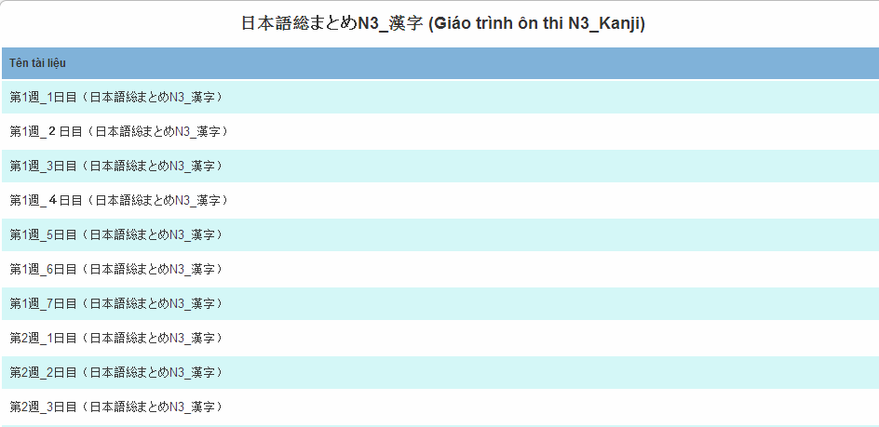

After click on hyperlink of N3 kanji:

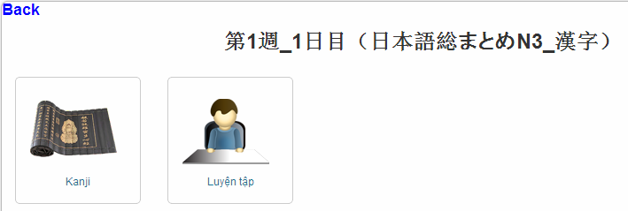

|  |  |  |  |  |  |  |
| --- | --- | --- | --- | --- | --- | --- |
| No | Field name | Type | Require | Mandatory | Length | Description |
| 1 | Back | Hyperlink | Click | N |  | Back on N3 kanji list |
| 2 | Kanji | Hyperlink | Click | Y |  | Kanji of N3 |
| 3 | Exercise | Hyperlink | Click | Y |  | Exercise of N3 kanji |

Kanji screen:

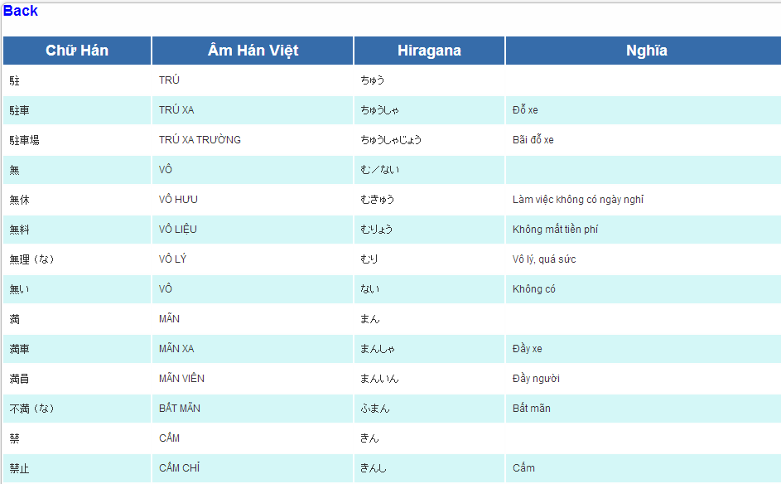

Exercise screen:

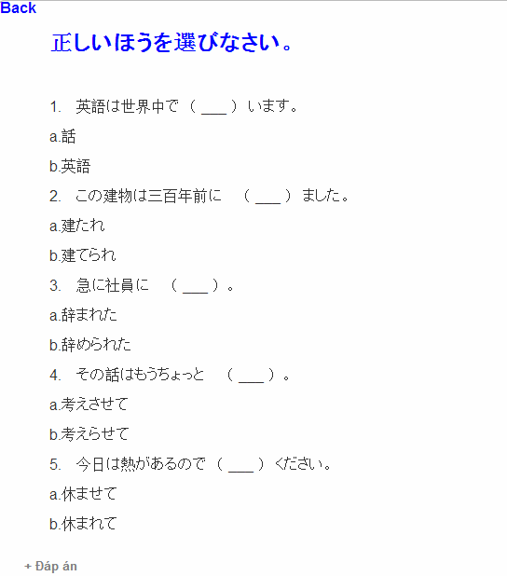

* + 1. N3 Reading

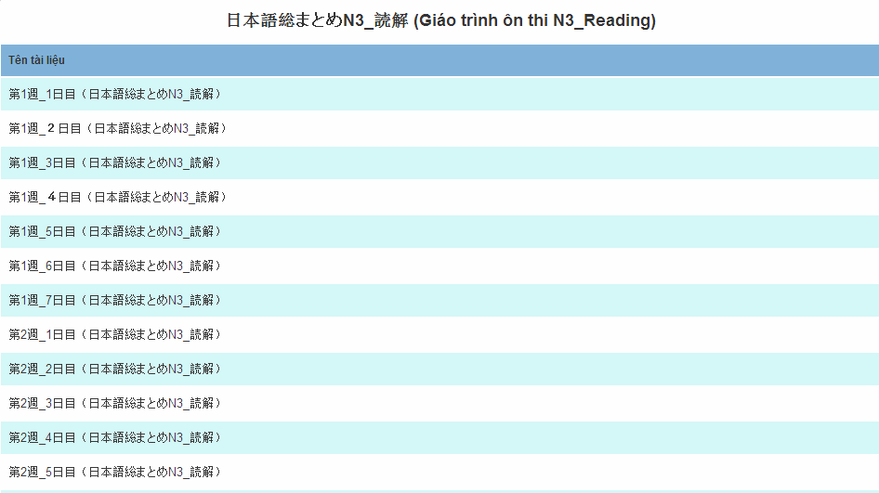

After click on hyperlink of N3 reading:

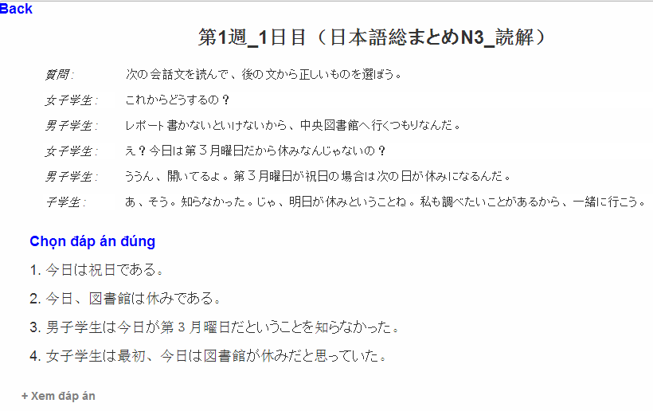

* + 1. N2 Grammar

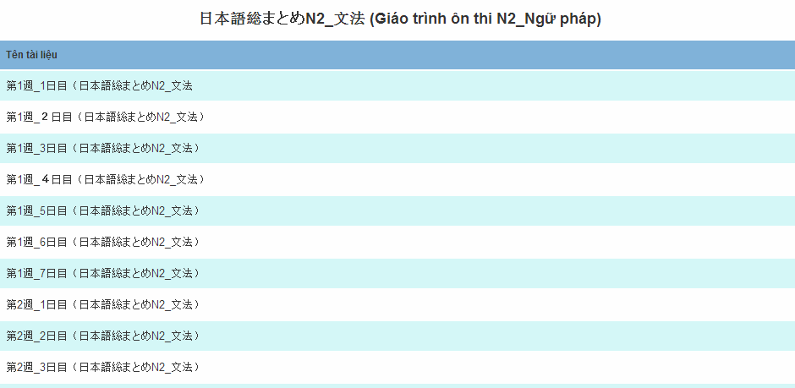

* + 1. N2 Vocabulary

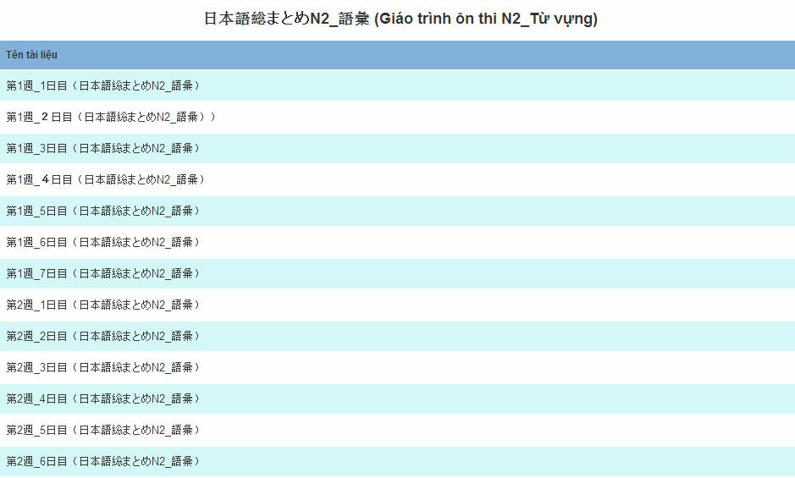

* + 1. N2 Kanji

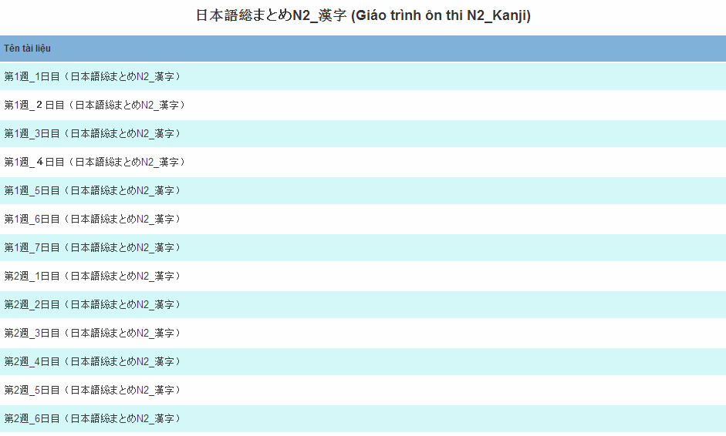

* + 1. N2 Reading

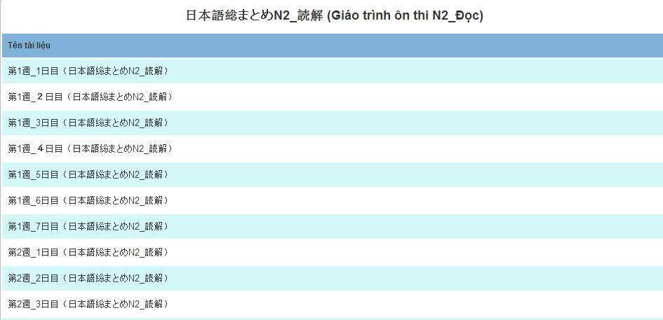

## Review

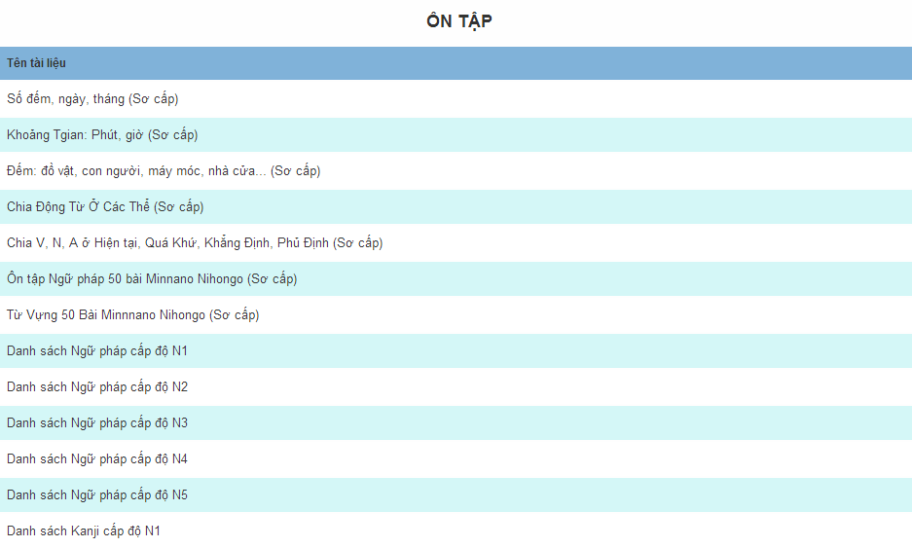

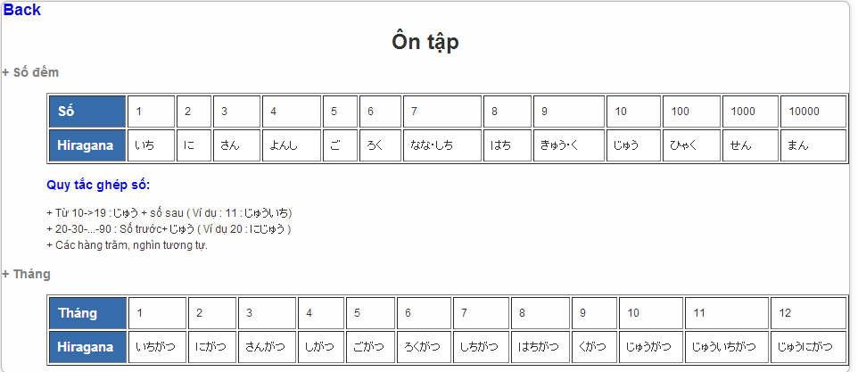

## Listening

* + 1. N2&N3

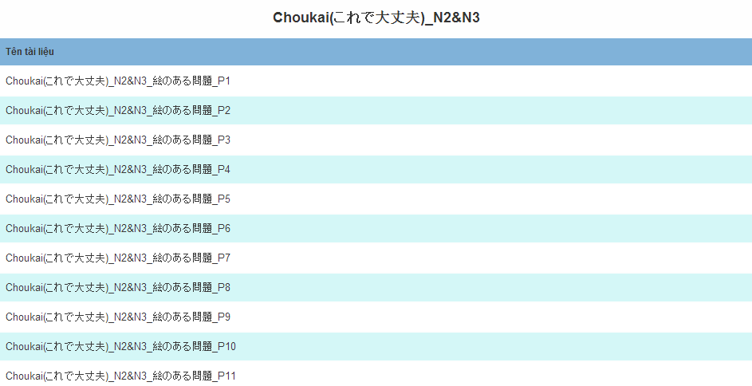

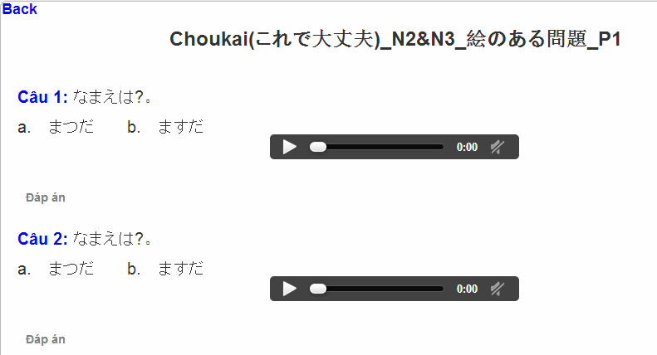

* + 1. N4&N5

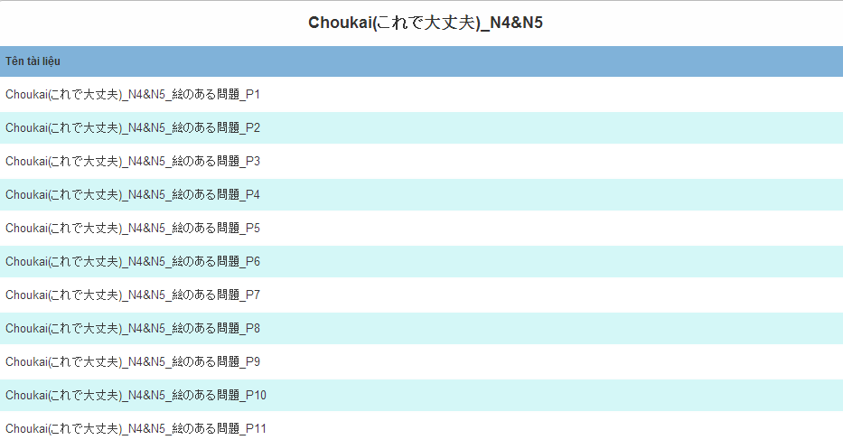

* + 1. N2 Listen

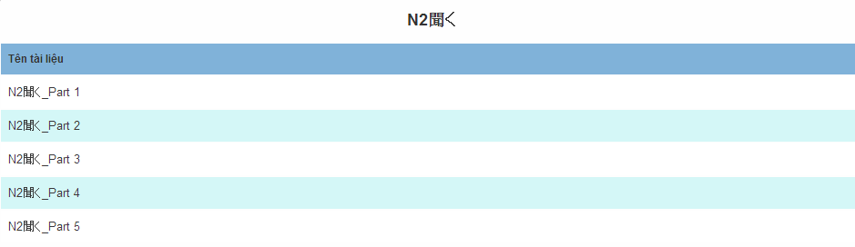

* + 1. N3 Listen

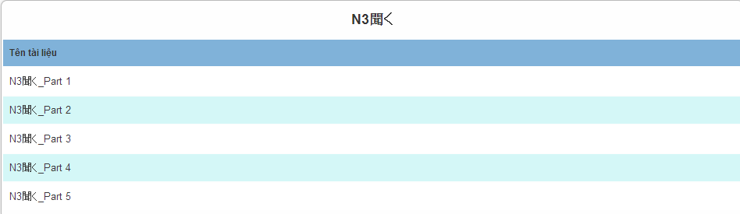

## Conversation

* + 1. Elementary 1

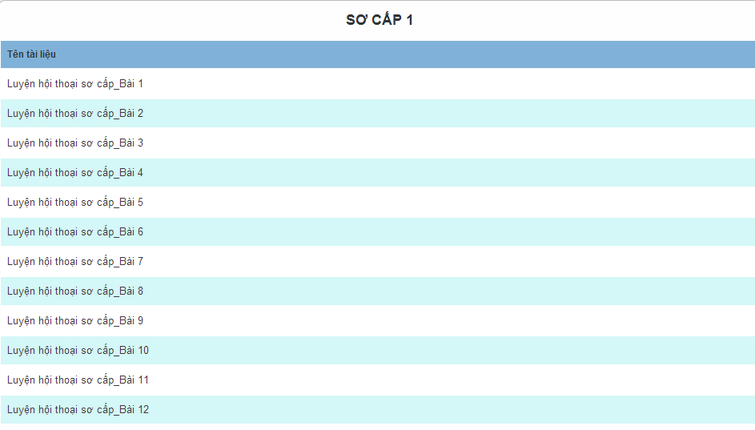

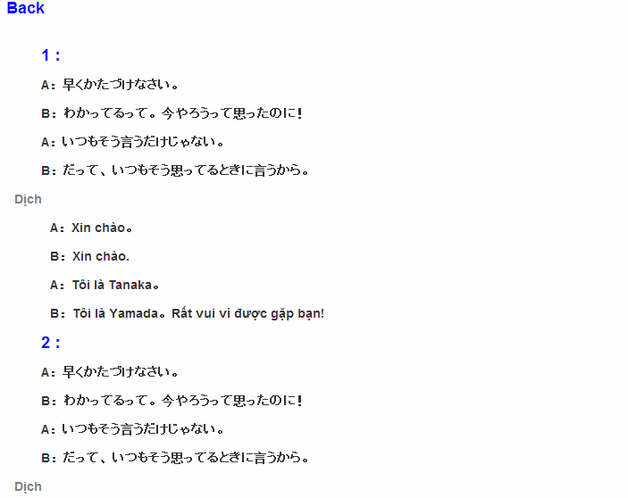

* + 1. Intermediate 1

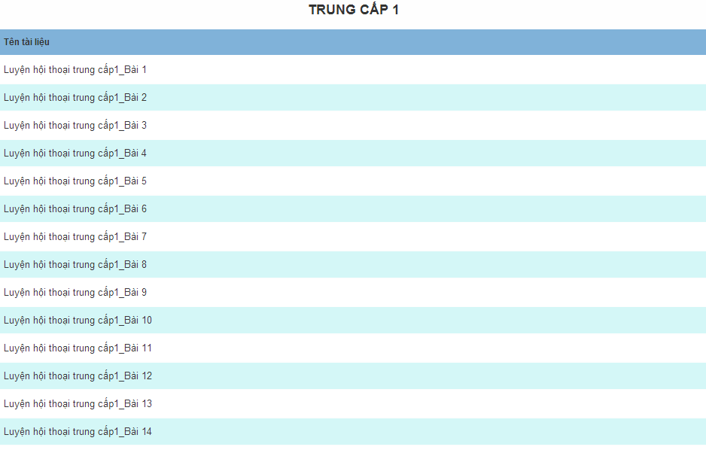

* + 1. Intermediate 2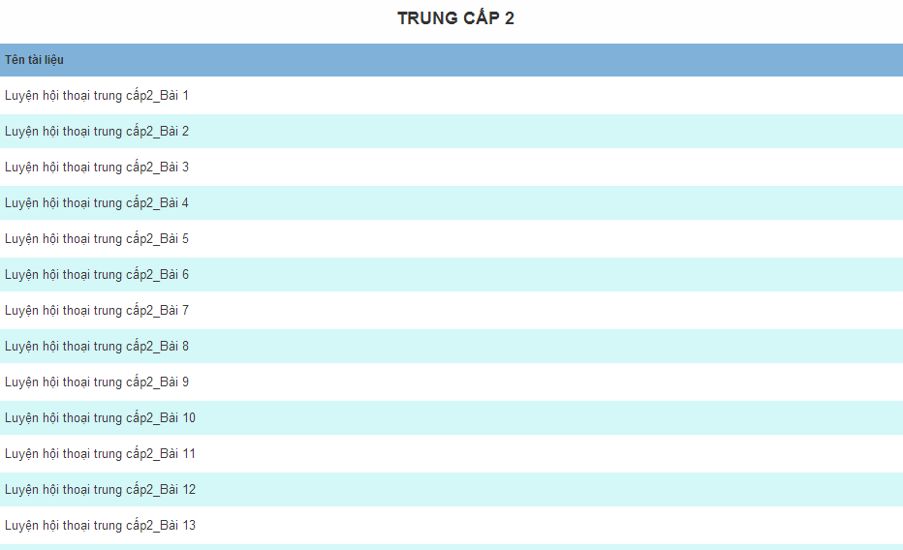

## Test

* + 1. N4 Test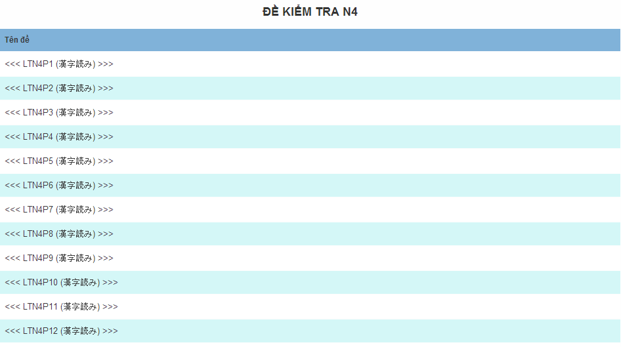

After click on hyperlink of N4 test:

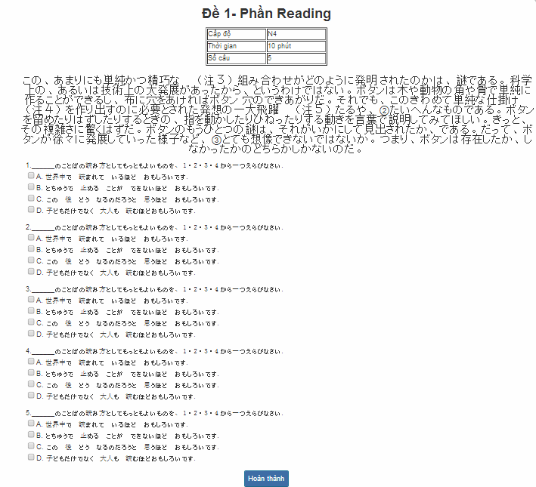

After done test:

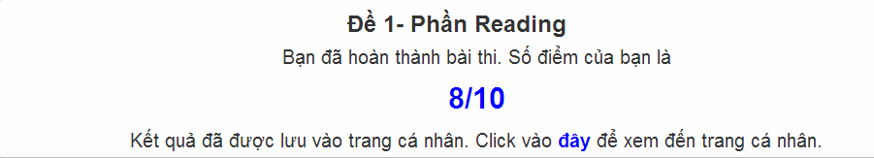

* + 1. N3 Test

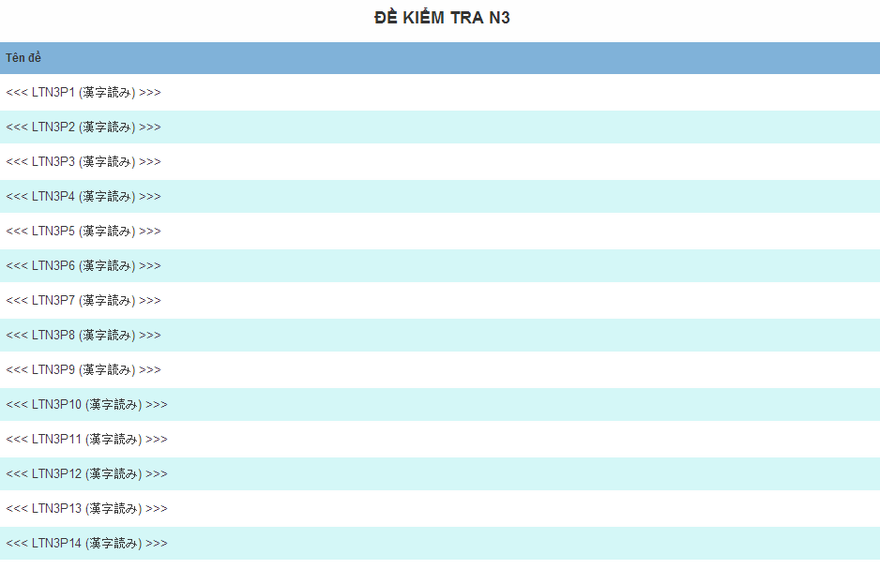

* + 1. N2 Test

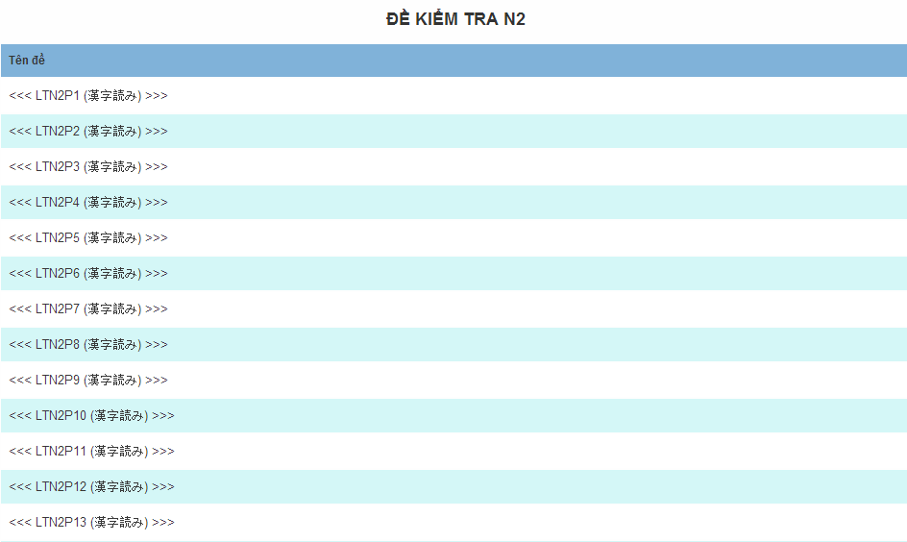

# Other considerations

**N/A**